Afera 4008 (EN 12026) Test Method

Adhesive Tapes - Measurement of the Unwinding Force at High Speed

1. Scope
This standard specifies a test method to determine the force required to unwind a roll of adhesive tape at high speed under defined conditions.

2. Summary of Test Method
A roll of adhesive tape is mounted on a core which can rotate without noticeable friction, joined to a testing machine which enables the tape to be unwound at a constant speed. and the unwinding force required under the test conditions is determined.

3. Apparatus
3.1 Unwinding equipment: a machine allowing adhesive tapes to be unwound at a constant speed under the following conditions:
- unwinding speed can vary between 15 to 120 metres/minute ± 3%. Where there is no variable speed, the following speeds will be predetermined: 30 metres/minute ± 3% and 60 metres/minute ± 3%.

- Within a range of at least 0 to 10 N and maximum 0 to 100 N, the reading of the measurement scale shall be possible with an accuracy of 0,5 N.
- The accuracy of the equipment shall be

± 1 % of the range of the measurement scale.

4. Test Specimens
4.1 The test specimens will consist of rolls measuring between 6 and 50 mm in width and more than 50 m long. Discard the first 3 turns of each roll before testing.

5. Procedure
5.1 The rolls to be tested shall be conditioned for 24 hours in the standard atmosphere prior to testing: (23 ± 2) °C and (50 ± 5)% relative humidity. The test shall be performed at the same conditions.

5.2 Place the roll on the unwinding machine. Start unwinding at the desired speed.

5.3 Read the unwinding force required every 15 seconds from the beginning of the unwinding process. Make at least 3 readings.

6. Results
6.1 Record the average of the values taken as being the value of the unwinding force.

6.2 Express the results in Newtons per centimetre (N/cm) width of tape, recording the unwinding speed used and the diameter of the core.

7. Report
The test report shall comprise:
- Reference to this Afera TM
- Full designation of the tested sample material
- Testing conditions
- Date of testing
- Results
- Any deviation from the procedure described in this method that may influence the results

Issued September 1979
Revised October 1981

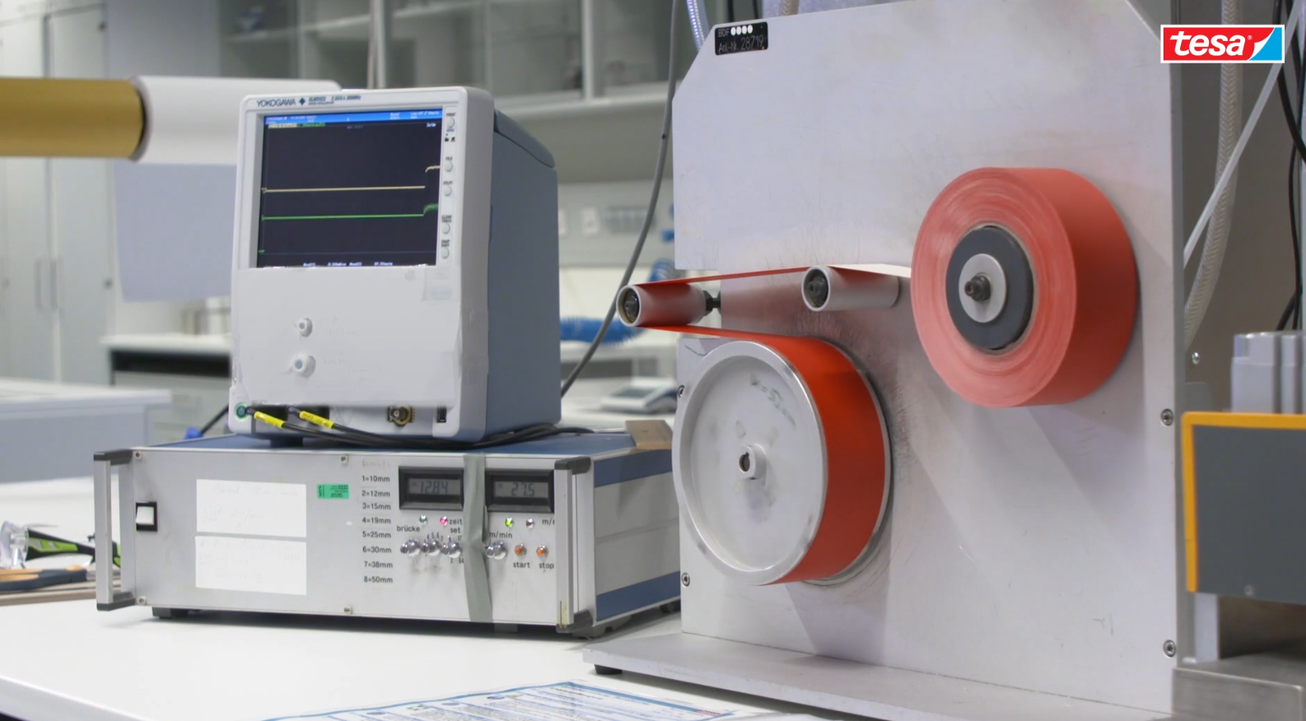

Figure 1 Device for measurement of unwinding force at high speed

